ADVANCED CYBERSECURITY CONCEPTS

ASSIGNMENT THOREY2

TASK1: In your virtual lab, create two VLANs (e.g., VLAN 10 for 'Marketing' and VLAN 20 for 'Sales') using your network simulator or virtualization tool, and assign at least one virtual machine to each VLAN.
Task 1: Create two VLANs and assign devices
We will create:
VLAN | Department | Network
VLAN 10 | Marketing | 192.168.10.0/24
VLAN 20 | Sales | 192.168.20.0/24

Step 1: Create the network topology
Open Cisco Packet Tracer.
Add these devices:
- 1 Switch (2960)
- 4 PCs
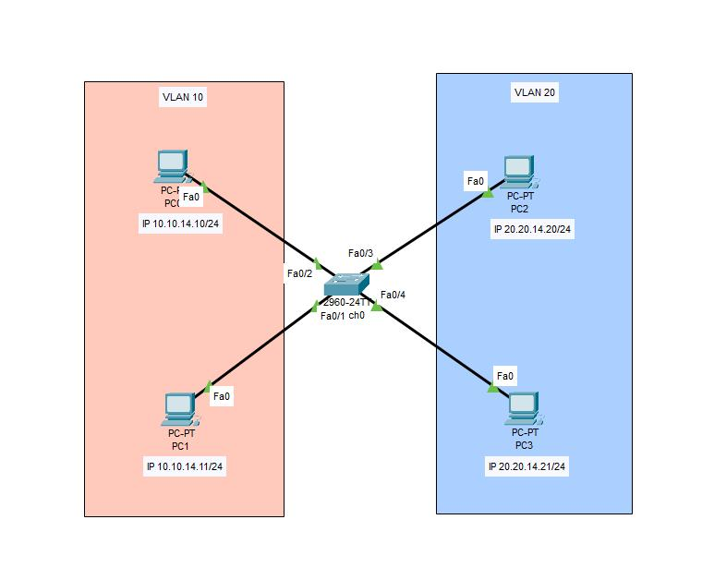
Step 2: Assign IP addresses to PCs
Device | VLAN | IP address | Subnet mask
PC0 | 10 Marketing | 192.168.10.2 | 255.255.255.0
PC1 | 10 Marketing | 192.168.10.3 | 255.255.255.0
PC2 | 20 Sales | 192.168.20.2 | 255.255.255.0
PC3 | 20 Sales | 192.168.20.3 | 255.255.255.0
Step 3: Create VLANs on the switch
Click the switch and open the CLI tab.
Enter these commands:
enable
configure terminal

vlan 10
name Marketing
exit

vlan 20
name Sales
exit
Step 4: Assign switch ports to VLANs
We will use ports Fa0/1 and Fa0/2 for Marketing, and Fa0/3 and Fa0/4 for Sales.
interface range fastEthernet 0/1-2
switchport mode access
switchport access vlan 10
exit

interface range fastEthernet 0/3-4
switchport mode access
switchport access vlan 20
exit

end
Step 5: Verify VLAN configuration
Run: show vlan brief

TASK2:Configure subnetting for the VLANs you created by assigning each VLAN a unique IP subnet (for example, 192.168.10.0/24 for Marketing and 192.168.20.0/24 for Sales), then verify that devices in the same VLAN can communicate with each other but not with devices in the other VLAN.<br><br><em><strong>Hint:</strong> Use the ping command from one VM to another within the same VLAN, and then try pinging across VLANs to test isolation.</em>
Step 1: Understand subnetting
Subnetting means dividing a network into smaller networks.
Here, we have created two separate subnets:
- Marketing: 192.168.10.0/24
- Sales: 192.168.20.0/24
Step 2: Test communication within Marketing
Click PC0 → Desktop → Command Prompt.
Enter: ping 192.168.10.3
Step 3: Test communication within Sales
Click PC2 → Desktop → Command Prompt.
Enter: ping 192.168.20.3
Step 4: Test communication between VLANs
From PC0, run: ping 192.168.20.2

TASK3: Set up a basic firewall rule in your virtual lab to block all traffic between the two VLANs, except for allowing only HTTP (port 80) traffic from Marketing to Sales. Document the rule you used and test the connectivity to confirm it works as intended.
Step 1: Understand the firewall rule
Source | Destination | Port | Action
Marketing | Sales | TCP 80 | Allow
Marketing | Sales | All other traffic | Block
Sales | Marketing | All traffic | Block

Step 2: Add a router
- Add a Cisco 1941 router to your Packet Tracer topology.
- Connect the router's G0/0 interface to the switch's G0/1 interface.
- The switch-to-router connection will carry traffic from both VLANs.
- Configure the switch port as a trunk.
enable
configure terminal

interface gigabitEthernet 0/1
switchport mode trunk
end
Step 3: Configure the router for both VLANs
Open the router CLI and enter:
enable
configure terminal

interface gigabitEthernet 0/0
no shutdown
exit

interface gigabitEthernet 0/0.10
encapsulation dot1Q 10
ip address 192.168.10.1 255.255.255.0
exit

interface gigabitEthernet 0/0.20
encapsulation dot1Q 20
ip address 192.168.20.1 255.255.255.0
exit
Step 4: Update the PC default gateways
Open each PC's Desktop → IP Configuration.
Device | Default gateway
PC0 | 192.168.10.1
PC1 | 192.168.10.1
PC2 | 192.168.20.1
PC3 | 192.168.20.1

Step 5: Create the firewall access-control rules
On the router, enter:
configure terminal

ip access-list extended MARKETING-IN
permit tcp 192.168.10.0 0.0.0.255 192.168.20.0 0.0.0.255 eq 80
deny ip 192.168.10.0 0.0.0.255 192.168.20.0 0.0.0.255
permit ip any any
exit

ip access-list extended SALES-IN
permit tcp 192.168.20.0 0.0.0.255 192.168.10.0 0.0.0.255 established
deny ip 192.168.20.0 0.0.0.255 192.168.10.0 0.0.0.255
permit ip any any
exit
Apply the rules to the router interfaces:
interface gigabitEthernet 0/0.10
ip access-group MARKETING-IN in
exit

interface gigabitEthernet 0/0.20
ip access-group SALES-IN in
exit

end
Step 6: Test the firewall rule
For an HTTP test, configure PC2 as a web server if your Packet Tracer version supports it:
- Click PC2 or add a Server device in VLAN 20.
- Open the Services tab.
- Select HTTP.
- Turn HTTP service ON.
- From PC0, open Desktop → Web Browser.
- Enter: http://192.168.20.2

TASK4: List three real-world apps (like Zomato, IRCTC, or Paytm) and describe one way each company could use network segmentation to improve their security or limit the impact of a cyber attack.
1. Zomato
- Use: Zomato can separate customer information, restaurant partner systems, and delivery management systems.
- Security benefit: If one section is attacked, the attacker cannot easily access all other sections.
2. IRCTC
- Use: IRCTC can separate ticket booking systems, payment systems, and employee administration systems.
- Security benefit: It helps protect payment and passenger information from unauthorized access.
3. Paytm
- Use: Paytm can separate payment processing, customer accounts, and internal employee systems.
- Security benefit: It reduces the risk of attackers moving from one system to another and accessing sensitive financial information.

